Q.1:

Ans: select FORMAT(HireDate,'MMMM') as 'Month_Name', count(BusinessEntityID) AS NumberOfEmployees from [AdventureWorks2019].[HumanResources].[Employee] group by FORMAT(HireDate,'MMMM');

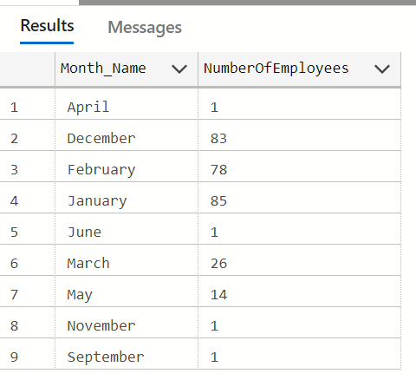

Q.2

Query: select Name, count( BusinessEntityID) AS NumberOfEmployees  from [AdventureWorks2019].[HumanResources].[Department] Inner Join [AdventureWorks2019].[HumanResources].[EmployeeDepartmentHistory] on EmployeeDepartmentHistory.DepartmentID = Department.DepartmentID group by Name

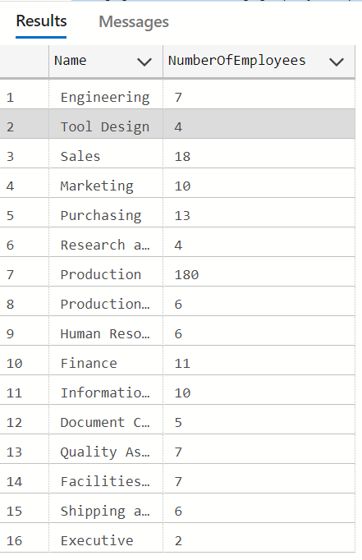

Q.4

Query: Select CONCAT(FirstName,' ',LastName) as Name, JobTitle, HR.OrganizationLevel, HR.BusinessEntityID

from [AdventureWorks2019].[Person].[Person] as p join [AdventureWorks2019].[HumanResources].[Employee] as

HR on p.BusinessEntityId = HR.BusinessEntityId where JobTitle IN ('Chief Executive Officer','Vice President of Engineering','Engineering Manager','Senior Tool Designer')  ;

Output:

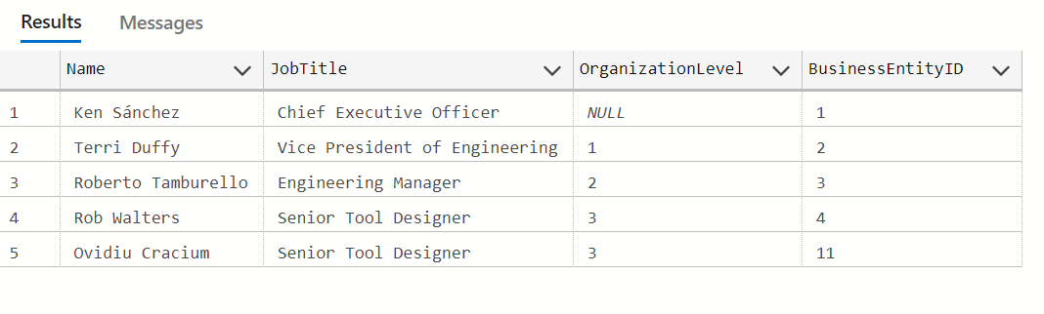

Q.3: select P.FirstName, CR.Name

from [AdventureWorks2019].[HumanResources].[Employee] as E

left join [AdventureWorks2019]. [Person]. [Person] P

on E. [BusinessEntityID] <> P. [BusinessEntityID]

left join [AdventureWorks2019].[Person].[BusinessEntityAddress] as BEA

on P. [BusinessEntityID] = BEA.[BusinessEntityID]

left join [AdventureWorks2019].[Person].[Address] A

on A. [AddressID]= BEA. [AddressID]

left join [AdventureWorks2019]. [Person].[StateProvince] SP

on SP.[StateProvinceID] =A. [StateProvinceID]

left join [AdventureWorks2019]. [Person].[CountryRegion] CR

on CR. [CountryRegionCode] = SP. [CountryRegionCode]

where P.FirstName like 'S%';

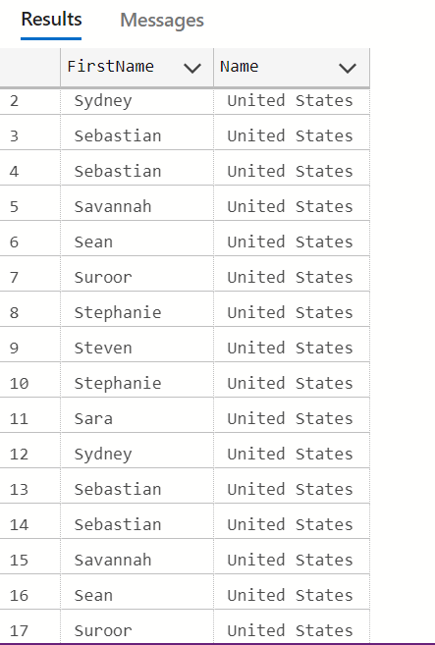

Q.5

Select p.productID,p.name,th.ActualCost as Commulative_sum,th.Quantity FROM [AdventureWorks2019].[Production].[Product] AS p ,[AdventureWorks2019].[Production].[TransactionHistory]

as Th where p.ProductID = th.ProductID;

